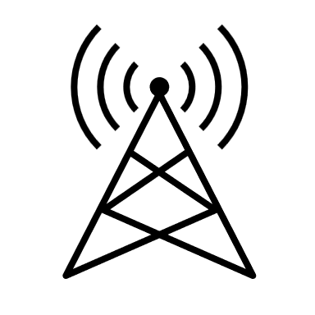



**C**

HARQ RSRP Threshold -Yet to be decided

|  |  |  |  |  |  |
| --- | --- | --- | --- | --- | --- |
| **UE** | **Synchronized by** | **SyncReF UE level** | **HARQ Received By** | **Traffic and Network data(DL)** | **Edge Server(V2N-UL)** |
| **A** | **gNB** | **Level 2** | **B** | **By gNB (V2N)** | **YES (V2N)** |
| **B** | **gNB** | **Level 2** | **A** | **By A (V2V)** | **NO** |
| **C** | **A** | **Level 3** |  |  |  |
| **D** | **Internal Clock** |  |  |  |  |

**`**

V2V RSRP Threshold -Yet to be decided

V2N RSRP Threshold α dBm

**B**

**A**

**D**

V2X RSRP Threshold -Yet to be decided

gNB/eNB